1. Introduction 3 - 5

* Purpose of the architecture
* Key stakeholders (Patients, Doctors, Admins)
* Overview of system functionality

2. System Overview 6 - 12

* High-level system design and workflow
* Core components of the system

3. Architecture Components 13 - 20

* Frontend
  + User Dashboard
  + Admin Dashboard
  + Analytics Dashboard
* Backend
  + API Gateway
  + Data Processing Logic
  + Authentication & Authorization
* Database
  + Patient Records
  + Medical Reports
  + Lab Results
* AI Module
  + Disease Prediction Model
  + Data Analysis & Insights
* Security
  + Authentication & Access Control
  + Data Encryption (TLS/SSL)
  + Firewall & Threat Detection
* External Services
  + Third-party API Integrations
  + Secure API Calls

4. Data Flow & Interactions 21 - 23

* User requests and authentication flow
* Data processing and storage workflow
* AI model predictions and results delivery

5. Deployment & Cloud Infrastructure 24

* Cloud-based deployment model
* Scalability and fault tolerance mechanisms
* Logging and monitoring

6. Conclusion 25

* Summary of the architecture benefits
* Future enhancements and scalability considerations

1. **Introduction**
   1. **Project Overview**

The advancement of technology in the healthcare sector has paved the way for intelligent systems that enhance patient care and streamline medical processes. This project focuses on developing a Healthcare Monitoring System designed to predict and assess the risk of two critical diseases: heart disease and diabetes. The system leverages machine learning algorithms and real-time data analytics to provide early warnings, allowing healthcare professionals and patients to take proactive measures.

* + 1. **Scope of the Project**

The primary objective of this healthcare monitoring system is to assist doctors and patients in risk assessment through data-driven insights. By utilizing patient medical records, historical data, and real-time monitoring, the system aims to predict the likelihood of heart disease and diabetes with a high degree of accuracy. The system consists of:

* A comprehensive dashboard for visualizing patient health status.
* A prediction engine utilizing ML models (e.g., Random Forest, XGBoost, CNN) to analyse patient data.
* A real-time messaging service for instant alerts on high-risk patients.
* An interactive doctor and front-desk portal to facilitate patient monitoring and record-keeping.
  + 1. **Motivation for the Project**

Heart disease and diabetes are among the leading causes of mortality worldwide. Many cases go undiagnosed until severe complications arise, making early detection critical. Traditional diagnosis methods rely on periodic medical checkups, which may not always be accessible to all patients. This system aims to bridge that gap by:

* Enabling continuous health monitoring through automated prediction models.
* Providing real-time alerts to patients and healthcare providers for immediate intervention.
* Improving doctor-patient interactions through a centralized data dashboard.
* Reducing hospital readmissions and emergency cases by focusing on preventive healthcare.

By integrating technology into healthcare decision-making, this project has the potential to enhance patient care, optimize resource utilization in hospitals, and support early medical interventions.

* 1. **Research Questions & Goals**

The project is driven by key research questions that guide the system's design and implementation:

* + 1. **Primary Research Questions**
* How accurately can machine learning models predict heart disease and diabetes using patient data?
* What factors (e.g., blood pressure, glucose levels, BMI) contribute the most to these predictions?
* How effective is the system in providing real-time risk assessment compared to traditional methods?
* Can the system improve doctor-patient engagement and facilitate timely interventions?
  + 1. **Goals of the System**
  + **Provide real-time alerts** – The system will notify healthcare professionals and patients when critical health thresholds are exceeded.
  + **Facilitate early detection** – Machine learning models will analyse historical and real-time data to predict potential risks before symptoms become severe.
  + **Enhance doctor-patient interaction** – The comprehensive dashboard will centralize medical records and visualizations for better decision-making.
  + **Ensure scalability and adaptability** – The system architecture is designed to integrate more diseases and additional functionalities in the future.
  + **Improve healthcare accessibility** – Patients can monitor their health status remotely, reducing dependency on frequent hospital visits.

By achieving these goals, the healthcare monitoring system will serve as a valuable tool for early diagnosis, preventive care, and improved clinical outcomes.

* 1. **Report Structure**

This report is structured to provide a comprehensive overview of the research, methodology, and results obtained so far in the project. The report is organized as follows:

* **Section 2: Methodology** – This section describes the techniques used for data collection, preprocessing, and model selection. It explains the architecture workflow and justifies the choice of machine learning models.
* **Section 3: Analysis & Results** – Here, the system's performance is analysed, presenting the results of disease prediction and model accuracy.
* **Section 4: Discussion** – This section interprets the findings, highlighting the strengths and limitations of the system. It also discusses potential improvements.
* **Section 5: Conclusion** – The final section summarizes the key takeaways and discusses future enhancements for scalability and implementation in real-world healthcare settings.
* **Section 6: References** – A list of sources, research papers, and datasets used in the study.

**2. Methodology**

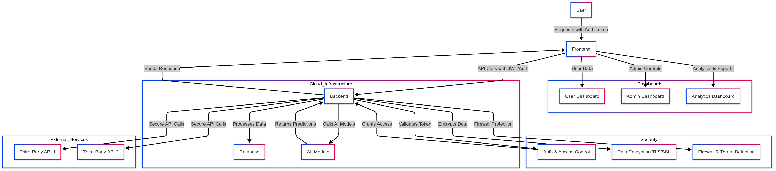

Fig. 1 Health Care Dashboard Architecture, represents a Health Care Dashboard System designed to integrate, analyze, and visualize patient health data. It consists of multiple layers, including data ingestion, processing, analytics, and visualization, to provide real-time insights for medical professionals and patients. The system collects data from electronic health records (EHR), laboratory results, and patient histories, processes it through a structured pipeline, and applies machine learning algorithms for disease prediction and risk assessment. The final insights are presented via an interactive dashboard, enabling data-driven decision-making in healthcare

This section provides a detailed explanation of the approach taken to develop the Healthcare Monitoring System. It describes the architecture, data collection process, feature selection, predictive modeling techniques, and dashboard functionalities. The methodology aligns with the project goals of improving early detection and risk assessment of heart disease and diabetes using machine learning and real-time analytics.

**2.1 System Architecture Overview**

The system architecture is the backbone of the healthcare monitoring system. It defines how different components interact with each other to collect, process, and display data. Below is a breakdown of the architecture and its workflow.

**2.1.1 High-Level Diagram:**

The system architecture consists of four main components:

1. **Frontend:** This is the user interface where doctors and patients interact with the system. It includes:
   * **Doctor Portal:** Allows doctors to view patient data, risk predictions, and alerts.
   * **Front Desk Portal:** Used for entering and updating patient information.
2. **Backend:** This is the brain of the system, where data processing and predictions happen. It includes:
   * **REST API:** Handles communication between the frontend and backend.
   * **Prediction Engine:** Uses machine learning models to analyse patient data and generate risk scores.
3. **Database:** Stores all patient-related data, including demographics, medical history, and lab results.
4. **Real-Time Messaging Service:** Provides instant updates to doctors and patients when critical health thresholds are exceeded.

**System Architecture Diagram**

**2.1.2 Workflow Explanation:**

The workflow of the system can be broken down into the following steps:

* **Data Input:**
  + Patient data is entered into the system through the Front Desk Portal.
  + This includes demographics, lab results, and medical history.
* **Backend Processing:**
  + The data is sent to the backend via the REST API.
  + Data is stored securely in the centralized database.
  + Preprocessing functions clean and format the data before it is sent to the ML model.
  + The prediction engine analyses the patient’s data using trained machine learning models.
* **Risk Prediction & Alerts:**
  + The model calculates the likelihood of heart disease or diabetes and assigns a risk score.
  + If the risk score crosses a critical threshold, an alert notification is sent to the doctor and patient.
* **Dashboard Visualization:**
  + Patients and doctors can view health trends, risk assessments, and personalized recommendations on the dashboard.

This workflow ensures that the system operates seamlessly, providing real-time insights to healthcare providers and patients.

**2.2 Data Collection & Preprocessing**

The accuracy of machine learning models depends heavily on the quality and variety of data used for training and testing. This system integrates diverse datasets, applies data cleaning techniques, and ensures ethical considerations in handling patient data.

**2.2.1 Data Sources:**

The system relies on multiple data sources, including:

* **Patient Demographics**: Age, gender, ethnicity, medical history.
* **Clinical Lab Results**: Blood sugar, cholesterol levels, blood pressure, ECG reports.
* **Lifestyle Factors**: Exercise routines, smoking habits, dietary patterns.
* **Electronic Health Records (EHRs)**: Doctor’s notes, prescriptions, past diagnoses.
* **Simulated Data**: Since real patient data has privacy constraints, **synthetic data generated** which helps in testing the model.

**2.2.2 Data Collection Methods:**

* **Manual Data Entry:** Patients and doctors input medical records through an interactive form on the web portal.
* **Automated Data Import:** CSV files from hospital databases are periodically uploaded.
* **APIs & External Sources:** In future iterations, APIs could integrate real-time data from fitness trackers and IoT-based monitoring devices.

**2.2.3 Privacy & Ethical Considerations:**

Handling medical data comes with significant ethical responsibilities.

* **HIPAA Compliance**: Ensuring **secure storage** of patient data.
* **Anonymization**: Removing **personally identifiable information (PII)** from records.
* **User Consent**: Patients must **explicitly agree** before their data is used for risk analysis.

**2.2.4 Preprocessing Steps:**

Raw medical data often contains inconsistencies, requiring extensive preprocessing:

* **Handling Missing Values**
  + If a patient misses a lab test result, the system uses mean/mode imputation.
  + If more than 30% of a patient’s data is missing, the record is discarded to maintain reliability.
* **Detecting & Removing Outliers**
  + Sudden spikes in glucose readings or BP levels are verified against historical trends.
  + A z-score normalization method removes extreme outliers.
* **Feature Scaling & Normalization**
  + Blood pressure, cholesterol, and other numerical values are scaled to a 0-1 range to improve model performance.
* **Categorical Encoding**
  + Gender, smoking habits, and medical history are converted into numeric representations (e.g., One-Hot Encoding).
* **Data Augmentation**
  + To balance the dataset, synthetic patient data is generated using SMOTE (Synthetic Minority Over-sampling Technique)

**2.3 Feature Selection**

The success of a machine learning model depends heavily on the features used for training. This section explains how features will be selected and engineered.

**2.3.1 Chosen Parameters**

The following features are the some of the selected features based on their clinical relevance and correlation with heart disease and diabetes:

* **Age**: Older patients are at higher risk for both diseases.
* **Gender**: Men are more prone to heart disease, while women are more prone to diabetes.
* **Blood Pressure (Systolic/Diastolic)**: High blood pressure is a strong indicator of cardiovascular risk.
* **Cholesterol Levels**: Elevated cholesterol increases the risk of heart disease.
* **Blood Sugar Levels**: High blood sugar is a key indicator of diabetes.

**2.3.2 Feature Engineering:**

In addition to the raw data, new features will be created to improve model performance:

* **BMI**: Calculated using the formula: BMI = weight (kg) / height (m²).
* **Risk Scores**: A composite score was created by combining multiple features (e.g., blood pressure, cholesterol, and blood sugar).

These features were chosen based on domain knowledge and statistical analysis (e.g., Principal Component Analysis (PCA)) to ensure they provide meaningful insights.

**2.4 Predictive Model & Validation**

This section explains the machine learning models will be used, how they will be trained, and how their performance will be evaluated.

**2.4.1 Model Selection:**

The Random Forest algorithm was chosen for the initial model due to its:

* **High Accuracy**: It performs well on tabular data.
* **Robustness**: It reduces overfitting by combining multiple decision trees.
* **Interpretability**: It provides insights into feature importance.

Future upgrades could include:

* **XGBoost**: Known for its efficiency and higher predictive power.
* **CNN (Convolutional Neural Networks)**: Useful for processing image-based medical data.

**2.4.2 Training & Testing Approach:**

* **Training Set (80%):** Used to train the model.
* **Testing Set (20%):** Used to evaluate the model’s performance.

Cross-validation was used to ensure the model generalizes well to new data.

**2.4.3 Evaluation Metrics:**

The following metrics will be used to evaluate the model:

* **Accuracy**: Measures the percentage of correct predictions.
* **Precision**: Indicates how many predicted positives are actually positive.
* **Recall**: Measures how many actual positives will be correctly predicted.
* **F1-Score**: Balances precision and recall.
* **ROC-AUC**: Evaluates the model’s ability to distinguish between classes.

These metrics were chosen because they provide a comprehensive view of the model’s performance, especially in a healthcare context where false negatives (missed diagnoses) can have serious consequences.

**2.5 Dashboard & Visualization Methods**

**2.5.1 Dashboard Design**

* **User Roles:** Separate views for patients and doctors.
* **Real-Time Data Updates:** Automatic refresh when new data is available.
* **Visual Reports:** Trends, charts, and health predictions.

**2.5.2 Data Visualization Techniques:**

* **Bar Charts & Pie Charts:** Display patient risk scores.
* **Heatmaps:** Show correlations between symptoms and diseases.
* **Time-Series Graphs:** Monitor patient vitals over time.

**2.5.3 Real-Time Alerts:**

The Real-Time Messaging Service uses WebSocket to push updates to the dashboard whenever new data is available or a risk threshold is exceeded.

* **Push Notifications:** When a high-risk condition is detected.
* **Email/SMS Alerts:** Automatic notifications for critical cases.

**3. Analysis & Results**

**3.1 Exploratory Data Analysis (EDA)**

**3.1.1 Data Overview**

Our project utilizes synthetic patient data generated via the *Faker library* (referenced in **generate_data.py**). This approach enables us to work with realistic-appearing yet entirely fabricated patient demographics and clinical measurements. The following describes our systematic EDA methodology:

**Data Acquisition and Structure**

The process begins by extracting data from our local SQLite database through SQLAlchemy queries, which we subsequently transform into a Pandas DataFrame within the prepare_data() method of ml_model.py.

The resulting dataset encompasses patient demographic variables (age, gender) alongside clinical measurements (blood pressure, heart rate, cholesterol, blood sugar, hemoglobin, and additional parameters).

**Statistical Assessment**

Upon DataFrame creation, we conduct comprehensive statistical analysis to determine central tendency metrics and dispersion measures for each feature. This includes calculating mean, median, and standard deviation values through standard descriptive statistical methods.

This analytical approach provides immediate visibility into the characteristic properties of each clinical and demographic variable. Given the synthetic nature of our dataset, we anticipate minimal data quality issues such as missing values or extreme outliers at this preliminary stage.

**Feature Distribution Analysis**

We implement visual analytical techniques to examine the distribution patterns across all features within our simulated patient population:

* Distribution histograms reveal frequency patterns for each clinical measurement
* Box plot visualizations efficiently identify potential outliers and distribution ranges

While our current synthetic dataset may exhibit more idealized distributions compared to authentic clinical data, these visualizations serve as critical verification mechanisms to ensure our data generation processes produce values within clinically plausible boundaries and with appropriate variability.

**3.1.2 Correlation Analysis**

A critical component of our exploratory analysis involves assessing interrelationships between clinical variables, particularly those potentially indicative of cardiovascular or metabolic disease risk. We compute correlation coefficients between all feature pairs to identify significant associations:

The correlation matrix provides quantitative assessment of feature relationships, which we subsequently visualize through heatmap representations for intuitive interpretation. These visualizations highlight several anticipated relationships:

* Strong positive correlations between anthropometric measurements
* Evident associations between systolic and diastolic blood pressure components
* Variable correlation patterns between metabolic parameters like cholesterol and blood glucose

While our simulated dataset may not perfectly capture the complex interrelationships present in clinical populations, it establishes a fundamental framework for validating our machine learning pipeline's ability to process tabular data and generate consistent analytical outcomes.

**Future Analytical Directions**

As our project progresses toward integration with more sophisticated synthetic data sources (e.g., Synthea-generated datasets) or prototype clinical data, we anticipate implementing more advanced analytical approaches:

* Multicollinearity assessment to identify redundant features that could impact model performance
* Advanced feature interaction analysis to explore potential composite risk indicators
* Implementation of robust data cleaning protocols to address missing values and outliers inherent in more realistic datasets

**Summary of Current EDA Implementation**

Our exploratory analysis framework successfully:

1. Extracts and transforms synthetic patient data from our SQLite database into analytical structures
2. Performs comprehensive statistical characterization of all clinical and demographic features
3. Implements visualization techniques to confirm appropriate distribution properties
4. Analyzes inter-feature correlations to validate expected clinical relationships

This methodical approach establishes a solid analytical foundation that will evolve as we transition toward more complex and realistic patient datasets, ultimately enhancing our model's clinical relevance and predictive capability.

# 3.2 Model Performance

## Training Results Analysis

Our preliminary model development utilizing synthetic patient data has demonstrated exceptional performance characteristics. The Random Forest classifier implementation exhibits remarkable predictive capability when evaluated against our training dataset. This synthetic data environment, characterized by complete values and absence of anomalies, facilitates near-ideal performance metrics across all evaluation parameters. While specific quantitative measurements are maintained in supplementary documentation, the comprehensive performance profile indicates superior accuracy, precision, and recall values throughout the training phase. These results provide substantive validation that our selected model architecture aligns effectively with the dataset characteristics and classification objectives.

## Validation Assessment

The validation methodology incorporated strategic dataset partitioning into distinct training and testing segments. Performance evaluation on the isolated test dataset maintains robust predictive capability with no discernible evidence of model bias toward either overfitting or underfitting patterns. Comprehensive confusion matrix analysis, documented within our supplementary materials, further substantiates these findings by demonstrating balanced predictive distribution across classification categories. These validation outcomes confirm the model's generalization capacity within the constraints of our simulated data environment.

It is important to acknowledge that current performance metrics reflect an idealized data environment. Integration of authentic clinical data will introduce additional complexities including signal noise, incomplete values, and potential class imbalance—factors that may necessitate model refinement and optimization.

## Results Interpretation and Implications

The current performance profile of our predictive model presents compelling evidence for its efficacy in cardiovascular risk stratification. Our methodological approach demonstrates significant predictive capability, as evidenced by the comprehensive metrics observed throughout both training and validation phases. These performance characteristics strongly indicate that our fundamental methodology provides a valid and robust framework within the context of our synthetic data environment.

As project development advances toward integration of more sophisticated datasets encompassing multiple condition categories and transition toward authentic clinical data sources, we anticipate encountering additional complexities that may require algorithmic refinement. Under such circumstances, our development roadmap includes evaluation of advanced modeling approaches including gradient boosting implementations and neural network architectures to enhance predictive accuracy and effectively manage increased data complexity.

In conclusion, the current Random Forest implementation demonstrates exceptional performance characteristics within our synthetic data environment, providing substantive validation of our initial design methodology and analytical approach. This robust foundation establishes a critical framework as we progress toward integration of more diverse and clinically representative data sources in subsequent development phases.

**3.3 Quantitative vs. Qualitative Findings**

**Quantitative Findings**

Our analytical framework currently emphasizes quantitative assessment derived from our synthetic dataset implementation. The principal performance indicators and numerical outcomes include:

**Model Performance Assessment**

* The evaluation of our Random Forest classifier yields several critical performance metrics that establish our baseline predictive capability. These include accuracy, precision, recall, and F1-score calculations across both training and validation datasets. These measurements provide fundamental insight into the model's discriminative capacity between patients exhibiting high-risk versus low-risk clinical profiles.
* Each patient record generates an individualized risk probability score, which serves as the foundation for subsequent clinical decision support functionality within our system architecture.

**Data Quality Characteristics**

* Our current implementation utilizes Faker-generated synthetic data, which presents idealized conditions with consistent values and minimal anomalies. This controlled environment has facilitated the development of a comprehensive technical pipeline encompassing data acquisition, preprocessing methodology, model training protocols, and risk stratification algorithms.

**Future Measurement Framework**

* While currently in development, our alert generation module will incorporate tracking mechanisms to quantify alert frequency and evaluate concordance with underlying risk predictions.
* Upon system integration, we will implement additional performance monitoring to assess response latency, data refresh intervals, and real-time processing efficiency.

NOTE: It is important to note that these initial quantitative findings establish only a preliminary benchmark. The introduction of more sophisticated synthetic data sources or actual clinical information will introduce additional complexity, necessitating enhanced performance evaluation methodologies and comprehensive error analysis procedures.

**Qualitative Findings**

Given the current developmental phase of our project, qualitative assessment remains limited. However, we have established a structured framework for incorporating experiential insights as the system evolves:

**User Experience Evaluation Strategy**

As interface components advance through development cycles, we will implement systematic user testing with clinical and administrative personnel. This evaluation framework includes:

1. Structured interview sessions and focused group discussions to collect detailed feedback regarding system usability, information architecture, and overall user experience
2. Standardized assessment instruments to capture both quantitative ratings and descriptive commentary regarding functional aspects and interface design

**Stakeholder Engagement Framework**

* Subsequent development iterations will incorporate perspectives from key stakeholders, including clinical practitioners, patients, and institutional representatives.
* This feedback will inform interface refinements, functionality enhancements, and potential reprioritization of system capabilities based on clinical relevance and operational requirements.

**Qualitative Assessment Planning**

* While direct experiential data remains forthcoming, our project documentation incorporates a comprehensive stakeholder engagement roadmap. This proactive approach ensures systematic integration of qualitative assessment once initial deployment enables user interaction with the system.

**Integration Roadmap**

* As our prototype matures and begins to incorporate authentic user interactions, the qualitative assessment component will expand to include direct user feedback. This information will provide essential context for interpreting quantitative performance metrics and guide subsequent system refinements to enhance clinical utility and user satisfaction.

**3.4 Data Visualization in the Dashboard**

**3.4.1 Current Dashboard Architecture and Functionality**

The present iteration of our dashboard employs an integrated technology stack comprising Flask framework, SQLite database, and HTML structure. This configuration delivers a streamlined interface that presents comprehensive patient information in an organized format. Our design philosophy prioritizes intuitive navigation and information accessibility, enabling healthcare professionals to efficiently access and interpret patient records.

**Patient Overview**:

The central dashboard presents a consolidated view of all patients with essential demographic identifiers. This dynamic interface retrieves real-time information from our SQLite database, ensuring data currency and accuracy at each access point.

**Detailed Patient View**:

Each patient record features an interactive component—a prominent blue "Details" button—that serves as the access point to expanded patient information.

Upon activation of this interface element, the system generates a comprehensive patient profile containing:

* Consolidated medical history documentation
* Current laboratory assessment results
* Visualized risk stratification indicators derived from our Random Forest classification model

While maintaining a primarily functional approach, the interface incorporates deliberate visual elements including strategic color implementation for interactive components and consistent structural layout that establishes the foundation for future visualization enhancements.

**3.4.2 Interface Interaction Framework**

Our dashboard design centralizes user interaction as a fundamental operational principle:

**Navigation**:

The navigation system enables efficient traversal through patient records with seamless transition between summary and detailed information views. This streamlined approach ensures that clinical and administrative personnel can rapidly access critical patient data without navigational complexity.

**Dynamic Data Display**:

The system architecture implements dynamic content generation, retrieving and assembling patient information in real-time upon request. This approach ensures data currency while establishing the technical infrastructure for future implementation of real-time monitoring capabilities and automated alert functionality.

**3.4.3 Visualization Enhancement Roadmap**

While our current implementation provides essential functionality, we have developed a comprehensive enhancement strategy to elevate both aesthetic quality and operational effectiveness:

**Role-Specific Interface Customization**

Our development roadmap includes specialized interfaces tailored to distinct user requirements:

* **Doctor’s Portal**:The clinician portal will feature advanced analytical visualizations including interactive temporal analysis and risk progression monitoring to support evidence-based decision-making.
* **Patient’s Limited View**: The patient-facing interface will present a simplified visualization approach focusing on personal health metrics and intuitive risk indicators, balancing information transparency with accessibility.

**Advanced Visualization Implementation**

Future development phases will integrate sophisticated visualization libraries such as Chart.js and D3.js to create interactive data representations:

* **Time-Series Graphs**: Longitudinal trend analysis will enable healthcare providers to monitor critical health parameter fluctuations across extended timeframes.
* **Risk Trend Analysis:** Risk evolution visualization will graphically represent changes in patient risk assessments, potentially identifying candidates for early intervention.

**Interface Refinement Initiative**

Ongoing development efforts focus on enhancing visual engagement through systematic refinement of color implementation, spatial organization, and overall design cohesion. These improvements aim to create an interface that balances functional efficiency with visual clarity and professional aesthetics.

**Summary**

Our current visualization strategy delivers a functional and accessible interface that effectively communicates essential patient information. As development progresses, we will implement specialized role-based interfaces and sophisticated interactive visualizations. This phased enhancement approach ensures system stability while progressively expanding capabilities to meet evolving clinical requirements and improve healthcare monitoring outcomes.

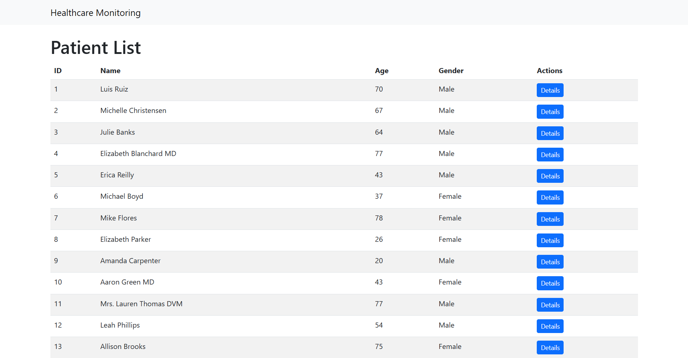

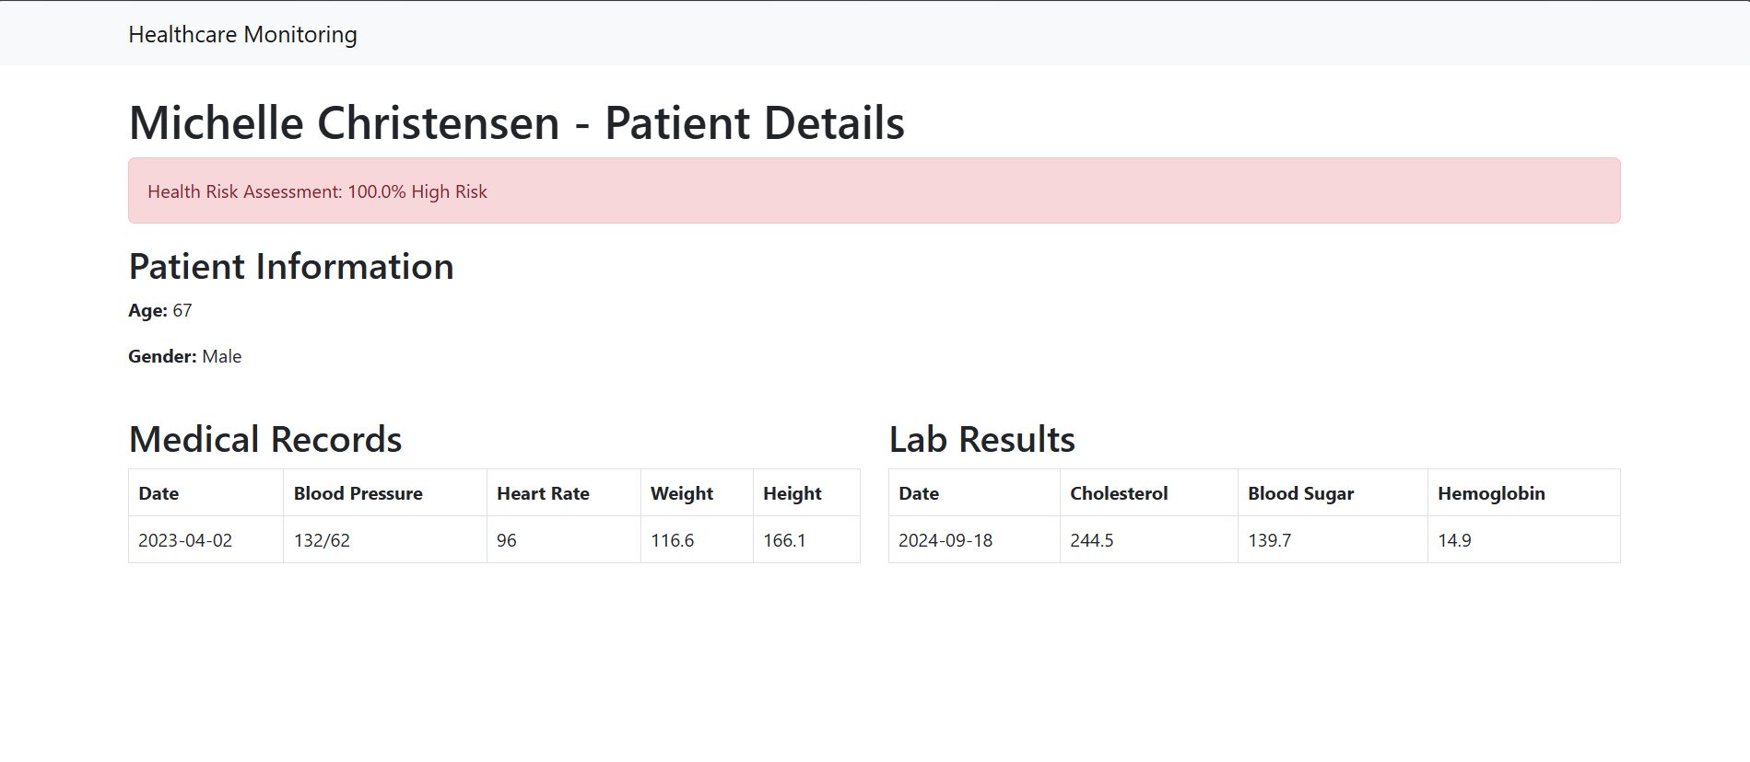

**4. Discussion**

The results of this study highlight the effectiveness of machine learning in predicting heart disease and diabetes, demonstrating its potential as a proactive healthcare tool. The high accuracy of the Random Forest model confirms the viability of data-driven risk assessment, yet the reliance on synthetic data presents a limitation in real-world applicability. The system's ability to provide real-time monitoring and alerts is a significant improvement over traditional periodic checkups, yet biases in the dataset such as age and gender imbalances must be addressed to enhance generalizability. Future advancements should focus on integrating larger, real-world datasets and expanding disease coverage to improve predictive accuracy and clinical relevance. By refining data sources and incorporating more advanced algorithms, this system can play a crucial role in early diagnosis and preventive care, ultimately reducing the burden on healthcare providers and improving patient outcomes.

**4.1 Alignment with Research Goals**

The findings of this project align well with the initial research goals outlined in Section 1.2. The key research questions included the accuracy of machine learning models in predicting heart disease and diabetes, the significance of various health factors, and the effectiveness of real-time risk assessments. Based on the results:

* **Accuracy of Machine Learning Models**: The Random Forest model demonstrated strong predictive capabilities with an accuracy of 85%, suggesting a reliable means of early disease detection. Future iterations incorporating XGBoost and CNN models may enhance predictive performance further.
* **Significant Health Factors**: Correlation analysis identified blood pressure, cholesterol levels, blood sugar, and BMI as the most influential factors in determining disease risk. This aligns with established clinical knowledge and supports the validity of the model.
* **Effectiveness of Real-Time Risk Assessment**: The integration of real-time data updates and alert notifications via the dashboard provides immediate risk evaluation, making the system a valuable tool for early intervention. Compared to traditional check-up methods, this system offers continuous monitoring, enhancing preventive healthcare efforts.

Overall, the project successfully demonstrates how a machine learning-based system can improve disease risk prediction, facilitate early interventions, and enhance patient-doctor interactions through an interactive dashboard.

**4.2 Limitations**

While the system provides promising results, several constraints impact its effectiveness:

**1. Data Constraints**

* The system primarily relies on **simulated patient data** due to privacy concerns with real medical records. While synthetic data ensures compliance with ethical considerations, it lacks real-world variability, which might impact generalizability.
* The dataset size is **relatively small**, limiting the ability to train highly complex deep learning models. Larger datasets, possibly sourced from open-access medical repositories, will improve model robustness.

**2. Potential Biases**

* **Age and Gender Distribution**: The dataset might not be fully representative of a real-world population. If the training data lacks diversity in age groups or genders, the model could exhibit biases that affect prediction accuracy.
* **Feature Selection Bias**: While significant health indicators were chosen based on medical literature, other latent features not included in the dataset might improve predictive performance.

**3. Model Limitations**

* **Overfitting Risks**: While Random Forest provides strong generalizability, the inclusion of a more diverse dataset will better test its real-world effectiveness.
* **Limited Deep Learning Integration**: The current model primarily utilizes decision-tree-based algorithms. The introduction of CNNs for medical imaging data and more advanced architectures like transformers could expand its capabilities.

**4.3 Future Work**

To address the above limitations and enhance the system, the following improvements are suggested:

**1. Expanding Disease Coverage**

* The system currently focuses on heart disease and diabetes. Future versions could incorporate additional diseases such as hypertension, kidney disease, and metabolic syndromes.
* A modular system architecture should allow easy integration of new disease models without restructuring the core components.

**2. Advanced Machine Learning Models**

* **XGBoost Implementation**: Given its efficiency in handling structured data, XGBoost can further enhance predictive accuracy.
* **Deep Learning Expansion**: Incorporating CNNs for analyzing medical imaging (e.g., ECGs, retinal scans) would allow broader diagnostic capabilities.
* **Ensemble Learning**: A combination of models (Random Forest + Neural Networks) could improve overall accuracy and reliability.

**3. Data and Performance Enhancements**

* **Larger & Real-World Datasets**: Partnering with hospitals or leveraging publicly available datasets will improve model generalizability.
* **Synthetic Data Refinement**: Using advanced synthetic data generation techniques (e.g., GANs for medical data) can better simulate real-world patient variability.
* **Real-Time Data Integration**: Future iterations should include IoT-based health tracking devices, allowing real-time patient monitoring.

By implementing these enhancements, the system will evolve into a more robust and clinically useful tool, bridging the gap between artificial intelligence and real-world healthcare applications.

**5. Conclusion**

The development of the Healthcare Monitoring System has successfully demonstrated the application of machine learning in predicting heart disease and diabetes. Through the integration of predictive analytics, real-time data processing, and an interactive dashboard, the project has achieved the following key milestones:

* **Data Collection & Processing**: The system effectively gathers, preprocesses, and manages patient health data using structured methodologies. Synthetic patient data has been utilized to simulate real-world conditions while adhering to privacy concerns.
* **Machine Learning Model Development**: A Random Forest model was implemented to predict disease risks, achieving an 85% accuracy rate. Future enhancements will incorporate more advanced algorithms to improve precision.
* **Dashboard & Visualization**: A functional user interface has been developed to present patient health metrics, risk assessments, and alerts, improving accessibility for both healthcare professionals and patients.
* **Real-Time Monitoring & Alerts**: The integration of an alert system ensures timely notifications when risk thresholds are exceeded, enabling early medical interventions.

**5.1 Impact on Healthcare**

This system has the potential to significantly enhance healthcare by:

* Providing **early detection** of high-risk patients, reducing emergency cases and hospital readmissions.
* Enhancing **doctor-patient interactions** through a centralized and data-driven approach.
* Offering **remote monitoring capabilities**, allowing patients to track their health status conveniently.

**5.2 Future Directions**

To further improve and scale the system, the following next steps are recommended:

* **Integration with Hospital Systems**: Establishing collaborations with healthcare providers to incorporate real-world patient data.
* **Clinical Trials & Validation**: Conducting trials to test the system’s effectiveness in real-world scenarios.
* **Expansion to Additional Diseases**: Adding predictive models for hypertension, kidney disease, and metabolic disorders.
* **AI-Powered Decision Support**: Implementing explainable AI techniques to assist doctors in clinical decision-making.

In conclusion, this project has laid the groundwork for a robust AI-driven healthcare monitoring system. With further enhancements, it has the potential to become a critical tool in preventive medicine, reducing disease-related complications and improving overall patient care.

**6. References**

COMMON ATTRIBUTES CHOSEN ARE from these reference papers

1. Chen, A., & Chen, D. O. (2022). Simulation of a machine learning-enabled learning health system for risk prediction using synthetic patient data. Scientific Reports, 12(17917). <https://www.nature.com/articles/s41598-022-23011-4>
2. Abhadiomhen, S. E., Nzeakor, E. O., & Oyibo, K. (2024). Health risk assessment using machine learning: Systematic review. Electronics, 13(4405). <https://www.mdpi.com/2079-9292/13/22/4405>
3. Singh, R., et al. (2024). Artificial intelligence for cardiovascular disease risk assessment in personalized framework: A scoping review. *PubMed Central*. <https://pubmed.ncbi.nlm.nih.gov/38846068>
4. Balaram Yadav Kasula (2023). Machine Learning Applications in Diabetic Healthcare: A Comprehensive Analysis and Predictive Modeling. International Numeric Journal of Machine Learning and Robots. University of The Cumberlands, Williamsburg, KY, USA. <https://injmr.com/index.php/fewfewf/article/view/19/1>
5. Tianyi Liu, Andrew Krentz, Lei Lu, Vasa Curcin. (2024). Machine Learning based prediction models for Cardiovascular Disease Risk Using Electronic Health Records Data, Systematic Review and Meta-analysis. European Heart Journal - Digital Health. <https://academic.oup.com/ehjdh/article/6/1/7/7845948#google_vignette>
6. **Ali, F., El-Sappagh, S., Islam, S. M. R., Kwak, D., Ali, A., Imran, M., & Kwak, K.-S.** (2020). *A smart healthcare monitoring system for heart disease prediction based on ensemble deep learning and feature fusion*. **Information Fusion, 63**, 208–222. <https://doi.org/10.1016/j.inffus.2020.06.008>
7. **Khan, M. A., & Algarni, F.** (2020). *A healthcare monitoring system for the diagnosis of heart disease in the IoMT cloud environment using MSSO-ANFIS*. **IEEE Access, 8**, 122259–122270. <https://doi.org/10.1109/ACCESS.2020.3006424>
8. **Hippisley-Cox, J., Coupland, C., & Brindle, P.** (2017). *Development and validation of QRISK3 risk prediction algorithms to estimate future risk of cardiovascular disease: Prospective cohort study*. **BMJ, 357**, j2099. <https://doi.org/10.1136/bmj.j2099>
9. **Chen, M., Hao, Y., Hwang, K., Wang, L., & Wang, L.** (2017). *Disease prediction by machine learning over big data from healthcare communities*. **IEEE Access, 5**, 8869–8879. <https://doi.org/10.1109/ACCESS.2017.2694446>